SYSTEM ARCHITECTURE AND DESIGN REPORT
AgriConnect: Technical Architecture for a Digital Agribusiness Platform
Junior Software Developer – Agribusiness Solution Internship
Week 2 Task: System Architecture and Design
Prepared by: Akash Srivastav
Internship Platform: YuvaIntern (NSDC)
Date of Submission: 25 September 2026

Table of Contents
1. Introduction 3
1.1 Recap of Week 1 3
1.2 Purpose of this Document 3
1.3 Scope 3
1.4 Architectural Goals & Design Principles 3
2. Research: Real-World Grounding and Architectural Patterns 4
2.1 Case Study: India's National Agriculture Market (e-NAM) 4
2.2 Connectivity Constraints 4
2.3 Digital Payments Context 5
2.4 General Architectural Patterns 5
3. High-Level System Architecture 6
4. Component Identification & Responsibilities 7
5. Detailed Module Design 8
5.1 User & Auth Service 8
5.2 Crop Listing & Inventory Service 8
5.3 Market Price Engine 9
5.4 Order & Logistics Service 9
5.5 Notification Service 10
5.6 Analytics & Reporting Service 10
6. Data Model Overview 10
7. Sequence Diagram: Place Order Flow 11
8. Deployment Architecture 12
9. Design Rationale 14
9.1 Scalability 14
9.2 Security 14
9.3 Modularity 14
10. Technology Stack Recommendations 14
11. Non-Functional Requirements Traceability 15
12. Assumptions, Constraints & Limitations 16
12.1 Assumptions 16
12.2 Constraints 16
12.3 Limitations & Future Considerations 16
13. Conclusion 17

1. Introduction

1.1 Recap of Week 1
The Week 1 Requirements Analysis Report established the foundation for AgriConnect, a digital marketplace and advisory platform connecting farmers, distributors, retailers, logistics partners, and platform administrators. That report identified seven stakeholder groups, ten sector-wide challenges, twelve user stories, four detailed use cases, twenty-seven functional requirements, and twelve non-functional requirements, organised across six functional modules: User Management, Crop Listing & Inventory, Market Price Engine, Order & Logistics, Notifications, and Administration & Analytics.
This Week 2 report takes that requirements catalogue as its starting point and translates it into a concrete, implementable system architecture.

1.2 Purpose of this Document
This document defines the technical architecture for AgriConnect: the system's major components, how they interact, how data flows through the system for a representative transaction, how the system is deployed and operated, and the technology choices that support the scalability, security, and modularity goals set out below. It is intended to guide the Week 3 Module Development task, in which selected components will be implemented.

1.3 Scope
This report covers the logical architecture (components and their responsibilities), a representative sequence diagram, the deployment and infrastructure topology, technology stack recommendations, and a traceability check against the Week 1 non-functional requirements. Detailed database schema definitions (DDL), infrastructure-as-code scripts, and full API specifications are intentionally out of scope here; these will be produced incrementally during Week 3 and Week 4 as specific modules are implemented.

1.4 Architectural Goals & Design Principles
The following principles guided every design decision in this report:
- Scalability – the system must absorb sharp, predictable demand spikes during regional harvest windows without manual intervention.
- Security – financial transactions and personal data must be protected in transit and at rest, with access tightly scoped by role.
- Modularity – component boundaries should mirror the six functional modules from Week 1, so a change in business requirements maps cleanly to a single component.
- Reliability & Availability – the platform must remain available during time-sensitive selling and pickup windows.
- Cost-efficiency – the architecture should suit an early-stage platform and a small engineering team, favouring managed services over bespoke infrastructure.
- Low-connectivity resilience – the design must tolerate intermittent rural network conditions on the client side.
- Interoperability – external systems (government price feeds, payment gateways, weather advisories) must be integrated without coupling their instability to core business logic.

2. Research: Real-World Grounding and Architectural Patterns in Agritech
Week 1's feedback asked for more concrete data and real-world reference points rather than general claims. This section grounds three of the architecture's key decisions — the price-data integration, the offline-tolerant client design, and the choice of payment rail — in a named, currently operating platform and recent public statistics, before summarising the general architectural patterns that follow from them.

2.1 Case Study: India's National Agriculture Market (e-NAM)
e-NAM (National Agriculture Market) is the Government of India's pan-India electronic trading portal for agricultural commodities, implemented by the Small Farmers Agribusiness Consortium (SFAC) under the Ministry of Agriculture and Farmers' Welfare. It is the closest real-world analogue to AgriConnect's Market Price Engine and crop-listing model, and its published statistics validate several of this report's design choices rather than leaving them as assumptions.
- Scale: the number of mandis integrated with e-NAM grew from 1,389 in 2024 to 1,656 as of March 2026, spanning 23 states and 4 union territories — evidence that a centralised government price feed is a viable, actively maintained integration target rather than a theoretical one.
- Coverage: as of December 2025, the platform provides free price information for 247 notified commodities, and reaches users through both a web portal and a dedicated mobile app (launched in 2016) — supporting this report's decision to treat the mobile client, not the web dashboard, as the primary interface for farmers.
- Interoperability model: in July 2022, e-NAM introduced a “Platform of Platforms” (PoP), allowing state and private agricultural e-marketplaces to interconnect with e-NAM through defined interfaces rather than each building siloed price infrastructure. This is the real-world precedent for the adapter pattern used throughout Section 4 to isolate every external integration — government price feed, payment gateway, weather API — behind a dedicated interface inside the owning service.
Practical implication for AgriConnect: the Market Price Engine's Govt. Mandi API adapter (Section 4, Section 5.3) is designed to consume a feed structured like e-NAM's — or the underlying Agmarknet price database it draws from — rather than a bespoke schema, so that switching or adding a state-level price source later is a configuration change to one adapter, not a redesign.

2.2 Connectivity Constraints (grounding NFR-1, NFR-5, NFR-11)
The client-side design assumptions in Week 1 (NFR-1 performance, NFR-5 usability, NFR-11 offline tolerance) are grounded in current national connectivity data rather than a general assumption of “poor rural internet”:
- Per the Telecom Regulatory Authority of India (TRAI), approximately 95% of Indian villages now have 3G/4G coverage and nearly 80% have 5G coverage — so network coverage itself is largely solved.
- The remaining gap is adoption and connection quality, not availability: rural internet penetration stands at roughly 42.8% of the rural population (about 440.7 million rural internet users) against a higher urban figure, and India's smartphone base of over 1.14 billion is still growing toward a projected 1.5 billion.
This distinction directly shapes the architecture: because coverage exists but session quality is inconsistent, the design favours client-side caching of recently viewed listings and prices (NFR-11) and a lightweight, low-bandwidth mobile client (NFR-5) over assuming an always-on, high-throughput connection — a subtly different problem than “no internet,” and one the caching and CDN layers in Section 3 are built to address.

2.3 Digital Payments Context (grounding the payment gateway decision, Section 9.2)
The decision to delegate all payment handling to a third-party gateway rather than process cards or bank transfers directly is grounded in the scale of India's Unified Payments Interface (UPI), operated by the National Payments Corporation of India (NPCI):
- UPI processed 23.2 billion transactions worth approximately ₹29.9 lakh crore in May 2026 alone, and now accounts for roughly 81–85% of the volume of India's retail digital payments.
- This scale means a UPI-enabled payment gateway is a mature, high-availability piece of national infrastructure — integrating with it is markedly lower-risk than building custom payment handling, and it keeps AgriConnect's own systems out of PCI-DSS card-data scope entirely (Section 9.2), since the Order & Logistics Service stores only a gateway reference and status, never card or account details.

2.4 General Architectural Patterns
Beyond these three grounded decisions, this section draws on patterns common to agritech and other marketplace platforms operating under similar constraints:
- Seasonal load spikes – traffic and transaction volume rise sharply during regional harvest windows, requiring elastic rather than fixed capacity.
- Unreliable third-party integrations – government price APIs and similar public data sources are often rate-limited or intermittently unavailable, requiring defensive integration patterns.
- Intermittent client connectivity – rural users' devices may lose connectivity mid-session, requiring offline-tolerant client design and idempotent APIs.
- Payment security and compliance scope – handling payments directly would pull the platform into a heavy compliance burden; delegating card handling to a gateway keeps scope manageable.
- Cost-sensitive infrastructure – early-stage agritech platforms typically cannot justify large, always-on infrastructure and benefit from pay-as-you-go managed services.
- Heterogeneous data quality – price and produce data arriving from multiple sources (farmers, government feeds) requires normalisation before use.
In response, this architecture adopts several well-established patterns: a microservices application layer behind a single API Gateway; an event-driven messaging layer to decouple slow or unreliable operations (such as SMS dispatch) from the main request path; a CDN and cache layer to reduce load on the primary database and improve performance on slow connections; an adapter pattern — modelled directly on e-NAM's Platform of Platforms approach — to isolate each external integration behind a dedicated interface; and client-side caching to tolerate intermittent connectivity. These patterns directly shape the architecture described in the remainder of this report.

Sources
Press Information Bureau, Ministry of Agriculture & Farmers' Welfare, Government of India – e-NAM progress release, March 2026. Telecom Regulatory Authority of India (TRAI) – telecom subscription and connectivity data, 2026. National Payments Corporation of India (NPCI) – UPI product statistics, May 2026.

3. High-Level System Architecture
AgriConnect adopts a layered architecture with a microservices application tier, fronted by a single API Gateway and backed by a shared data layer. An asynchronous messaging layer decouples time-sensitive but non-blocking operations — chiefly notification dispatch — from the main request/response path. External systems are reached only through the specific services that need them, never directly by clients. This structure was chosen because it satisfies the goals in Section 1.4 directly: independent services can be scaled, deployed, and reasoned about separately (modularity, scalability), the gateway centralises authentication and rate limiting so individual services stay simple (security), and the messaging layer prevents a slow external dependency, such as an SMS provider, from blocking an order confirmation (reliability).
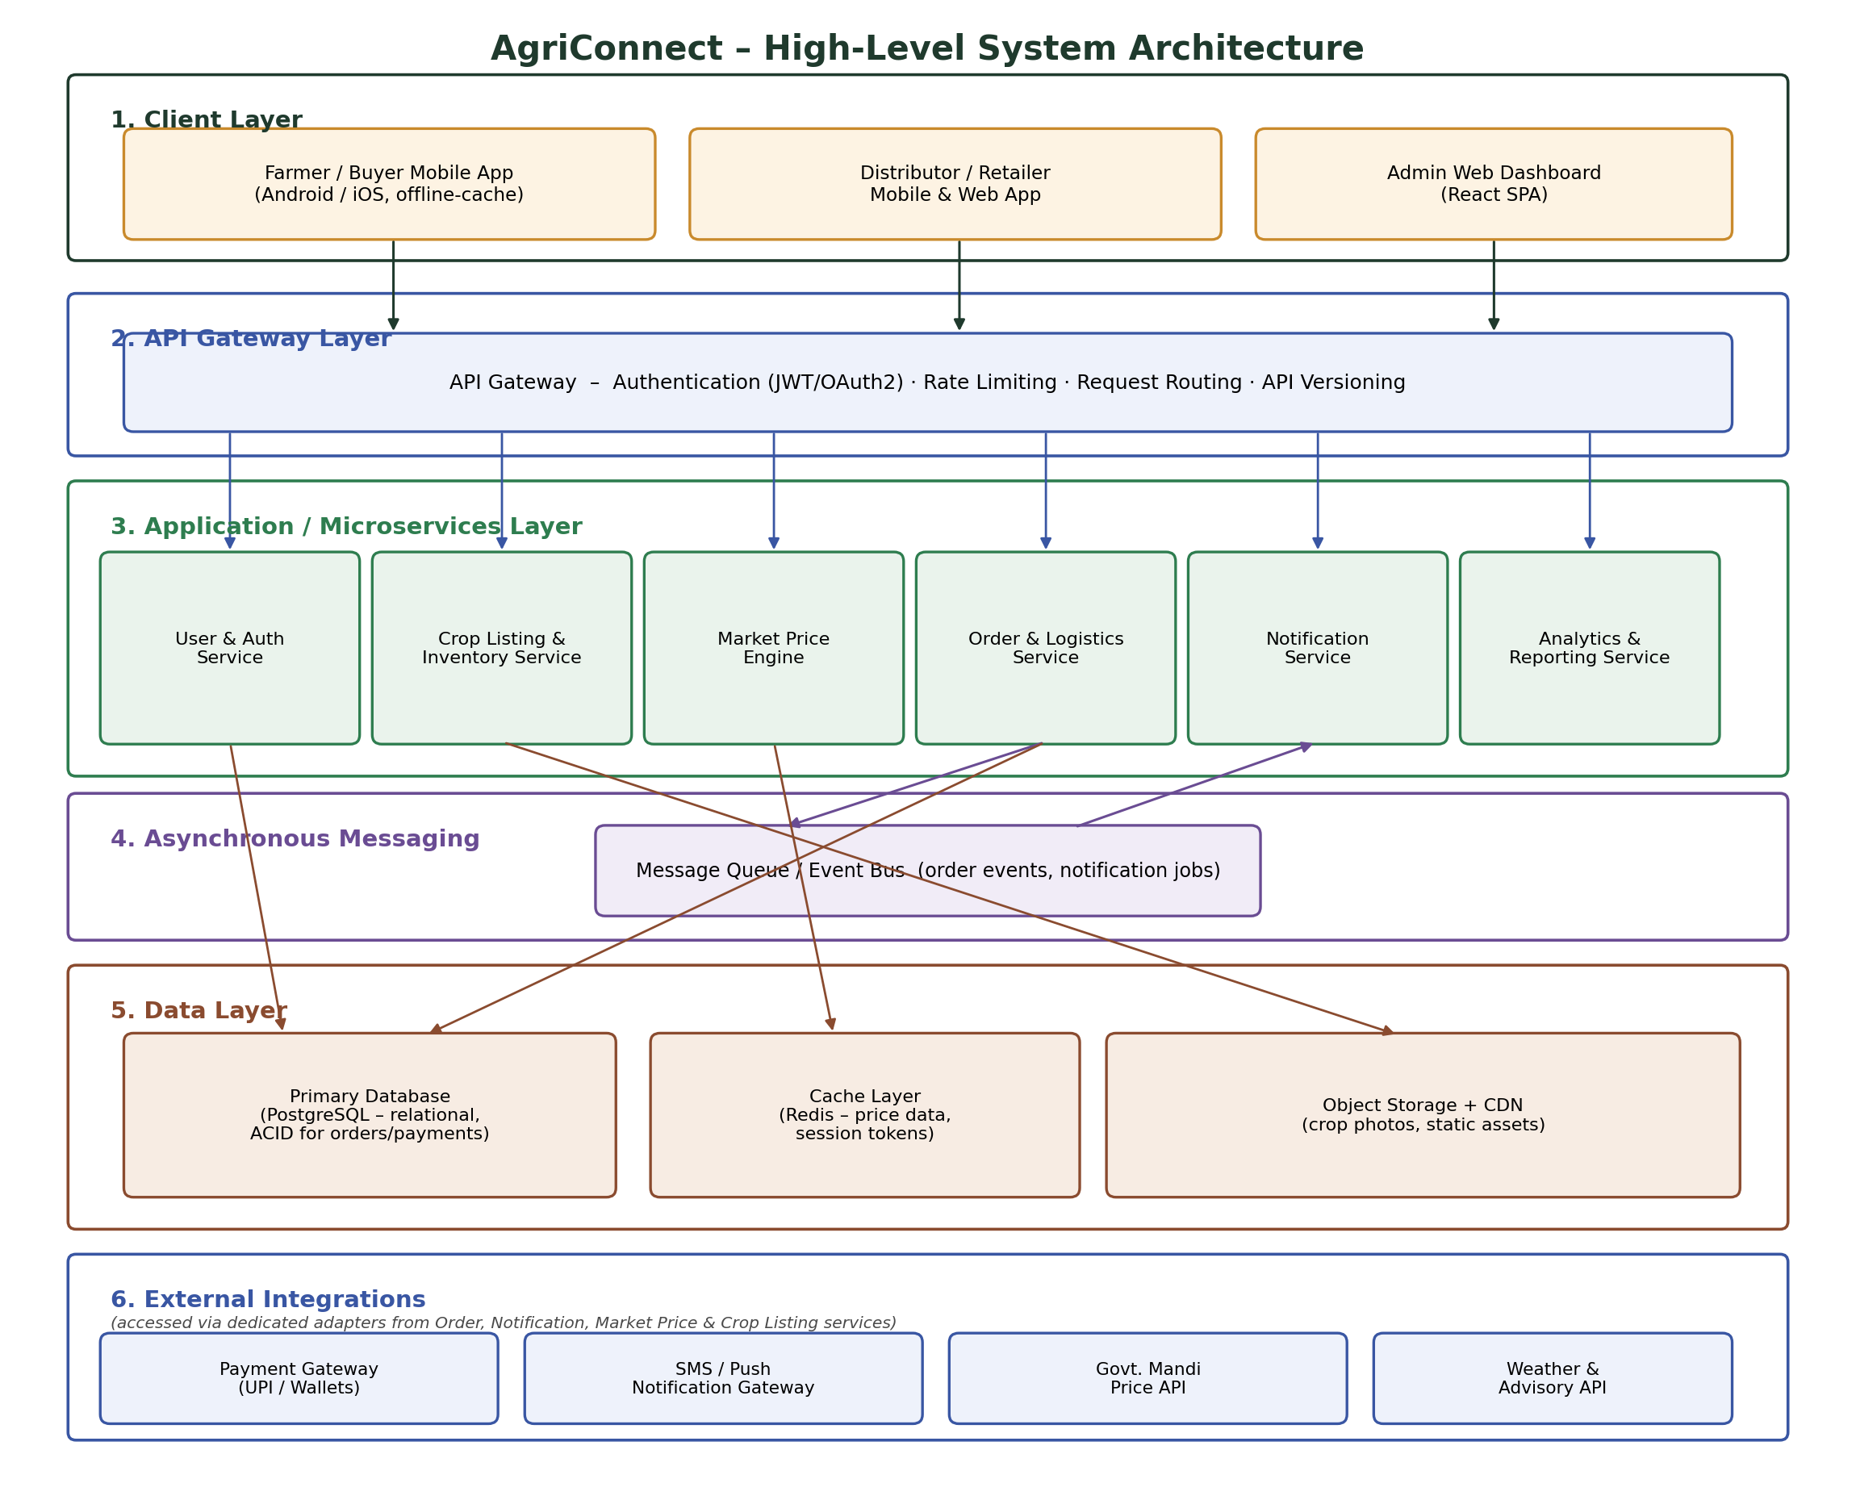
Figure 1: AgriConnect high-level system architecture, showing the client, gateway, application, messaging, data, and integration layers.

Layer-by-Layer Summary
- Client Layer – the farmer/buyer mobile app (with offline caching), the distributor/retailer app, and the admin web dashboard. All clients talk only to the API Gateway.
- API Gateway Layer – a single entry point handling authentication (JWT/OAuth2), rate limiting, request routing, and API versioning, so downstream services do not duplicate this logic.
- Application / Microservices Layer – six services, one per Week 1 functional module: User & Auth, Crop Listing & Inventory, Market Price Engine, Order & Logistics, Notification, and Analytics & Reporting.
- Asynchronous Messaging – a message queue carries order-related events from the Order & Logistics Service to the Notification Service, so notification delivery never blocks an order response.
- Data Layer – a relational primary database for transactional data, a cache for hot, frequently-read data such as prices and sessions, and object storage with a CDN for crop photographs and static assets.
- External Integrations – the payment gateway, SMS/push notification gateway, government mandi price API, and weather advisory API, each accessed through a dedicated adapter inside the relevant service.

4. Component Identification & Responsibilities
The table below identifies every major architectural component, its core responsibility, the recommended technology, and its principal dependency. Together these components implement the six functional modules and supporting infrastructure introduced in Section 3.
Component | Responsibility | Key Technology | Depends On
Mobile / Web Client Apps | Farmer, distributor, and retailer interactions; offline caching of recent listings and prices | React Native (mobile), React (web) | API Gateway
Admin Web Dashboard | Platform administration, user verification, analytics viewing | React SPA | API Gateway
API Gateway | Authentication, rate limiting, request routing, API versioning | Managed API Gateway | All backend services
User & Auth Service | Registration, OTP login, profile management, role-based access | Node.js / Express, JWT | Primary Database
Crop Listing & Inventory Service | Listing CRUD, search & filter, photo handling | Node.js / Express | Primary Database, Object Storage
Market Price Engine | Price display, trend calculation, threshold alerts | Node.js / Express | Cache, Govt. Mandi API
Order & Logistics Service | Order lifecycle, logistics assignment, shipment tracking | Node.js / Express | Primary Database, Payment Gateway, Message Queue
Notification Service / Worker | Consumes events, renders templates, dispatches SMS/push | Node.js worker | Message Queue, SMS/Push Gateway
Analytics & Reporting Service | Aggregates metrics, generates downloadable reports | Node.js / Express | Primary Database (read replica)
Message Queue | Decouples order events from notification dispatch | Managed queue (SQS / RabbitMQ) | –
Primary Database | System of record for users, listings, orders, payments | PostgreSQL | –
Cache Layer | Low-latency access to hot data: prices, sessions | Redis | –
Object Storage + CDN | Durable storage and edge delivery of crop photos, static assets | S3-compatible storage + CDN | –

5. Detailed Module Design
This section elaborates each of the six core microservices identified in Sections 3 and 4: their responsibilities, a representative sample of REST endpoints (full API specifications will be finalised during implementation), and the data entities each service owns.

5.1 User & Auth Service
Responsibilities:
  - Register new users with role selection (Farmer, Distributor, Retailer, Logistics Partner).
  - Authenticate users via OTP (mobile) or email/password, issuing JWTs.
  - Support administrator verification of new registrations before granting full access.
  - Manage profile edits and password resets.
  - Expose role information consumed by the API Gateway for access control.
Sample REST Endpoints:
Method | Endpoint | Description
POST | /api/v1/auth/register | Register a new user with a selected role
POST | /api/v1/auth/login | Authenticate via OTP or password, issue JWT
GET | /api/v1/users/{id} | Retrieve a user profile
PATCH | /api/v1/users/{id} | Update profile details
Data Owned: User, Role, VerificationStatus.

5.2 Crop Listing & Inventory Service
Responsibilities:
  - Create, edit, and deactivate crop listings.
  - Support search and filtering by crop type, location, price range, and quantity.
  - Flag listings nearing their harvest or expiry date.
  - Maintain a listing history per farmer.
Sample REST Endpoints:
Method | Endpoint | Description
POST | /api/v1/listings | Create a new crop listing
GET | /api/v1/listings | Search/filter active listings
PATCH | /api/v1/listings/{id} | Edit or deactivate a listing
GET | /api/v1/listings/{id}/history | Retrieve a farmer's listing history
Data Owned: CropListing, ListingPhoto, ListingHistory.

5.3 Market Price Engine
Responsibilities:
  - Fetch and cache current mandi prices from the government price API.
  - Calculate 7-day and 30-day price trends.
  - Support price comparison across nearby markets.
  - Trigger threshold-based alerts to subscribed farmers.
Sample REST Endpoints:
Method | Endpoint | Description
GET | /api/v1/prices/{cropId} | Current price for a crop
GET | /api/v1/prices/{cropId}/trend | Historical trend for a crop
GET | /api/v1/prices/compare | Compare prices across markets
POST | /api/v1/prices/alerts | Create a price threshold alert
Data Owned: PriceRecord, PriceAlertSubscription (cache-first, backed by a periodic sync job).

5.4 Order & Logistics Service
Responsibilities:
  - Create and confirm orders against a listing.
  - Orchestrate payment via the payment gateway adapter.
  - Assign a logistics partner and track shipment status.
  - Handle cancellations within a defined window, capturing a reason.
Sample REST Endpoints:
Method | Endpoint | Description
POST | /api/v1/orders | Place a new order
GET | /api/v1/orders/{id} | Retrieve order details and status
PATCH | /api/v1/orders/{id}/status | Update shipment status
POST | /api/v1/orders/{id}/cancel | Cancel an order with a reason
Data Owned: Order, OrderItem, Shipment, Payment (status/reference only – card data is never stored).

5.5 Notification Service
Responsibilities:
  - Consume order, price-alert, and weather-advisory events from the message queue.
  - Render message templates per event type and user language preference.
  - Dispatch messages via the SMS/push gateway and record delivery status.
Sample REST Endpoints:
Method | Endpoint | Description
GET | /api/v1/notifications/{userId} | Retrieve a user's notification history
PATCH | /api/v1/notifications/preferences | Update notification preferences
Data Owned: NotificationLog, UserPreference.

5.6 Analytics & Reporting Service
Responsibilities:
  - Aggregate listing, order, and user activity metrics for the admin dashboard.
  - Generate downloadable CSV/PDF activity reports for a selected period.
  - Read from a database read replica to avoid impacting transactional performance.
Sample REST Endpoints:
Method | Endpoint | Description
GET | /api/v1/analytics/summary | Platform-wide activity summary
GET | /api/v1/analytics/reports | Generate a report for a given period
Data Owned: Stateless aggregator; reads other services' data via the read replica, with its own ReportExportLog.

6. Data Model Overview
The table below summarises the core data entities that underpin the services described in Section 5, along with their key fields and relationships. A full entity-relationship diagram and schema definition will be produced during Week 3 implementation; this overview is sufficient to validate that the service boundaries in Section 4 have a coherent, non-overlapping data ownership model.
Entity | Key Fields | Related To
User | id, name, role, phone, verified | Owns CropListing; places Order
CropListing | id, farmerId, cropType, quantity, price, harvestDate, photoUrl, status | Belongs to User; referenced by OrderItem
Order | id, buyerId, listingId, status, totalAmount, createdAt | Has many OrderItem; has one Shipment and one Payment
OrderItem | id, orderId, listingId, quantity, unitPrice | Belongs to Order
Shipment | id, orderId, logisticsPartnerId, status, eta | Belongs to Order
Payment | id, orderId, gatewayRef, status, amount | Belongs to Order
PriceRecord | id, cropId, market, price, recordedAt | Referenced by Market Price Engine
NotificationLog | id, userId, channel, message, status, sentAt | Belongs to User

7. Sequence Diagram: Place Order Flow
The sequence diagram below traces a complete “place and confirm order” transaction end-to-end, corresponding to Use Case UC-2 from the Week 1 report. It illustrates how the API Gateway, Order & Logistics Service, Payment Gateway, Message Queue, and Notification Service collaborate, and shows explicitly where the flow is synchronous (the buyer waits for a response) versus asynchronous (the farmer's notification is decoupled from the buyer's confirmation).
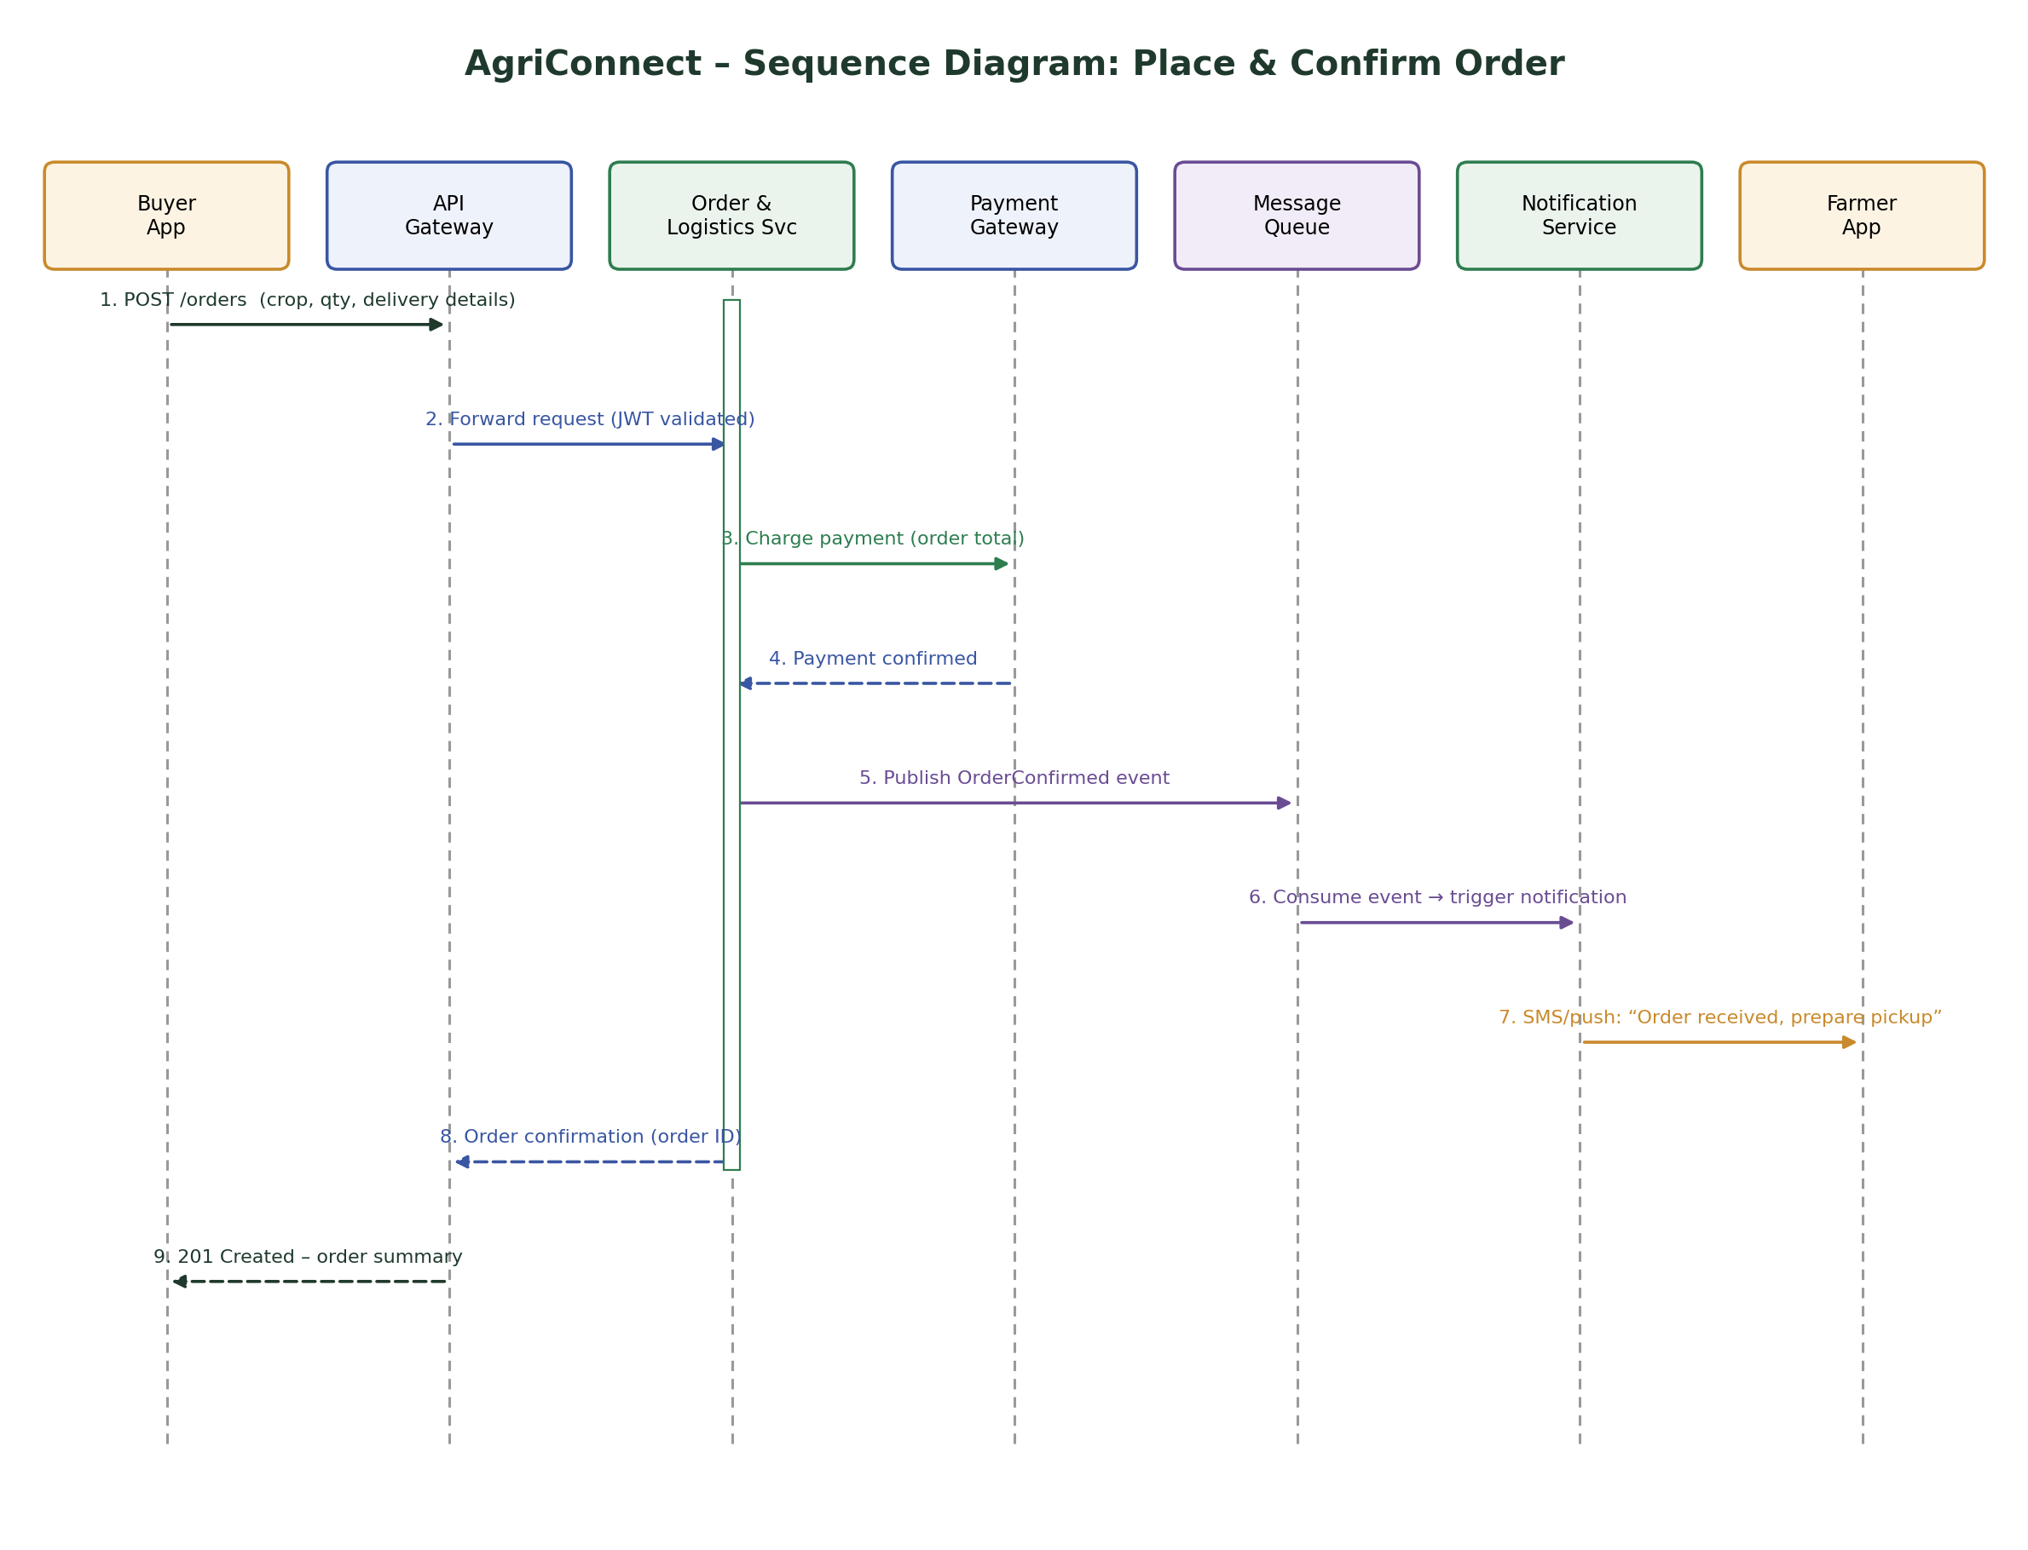
Figure 2: Sequence diagram for the place-and-confirm-order flow.

Flow Walkthrough
- Steps 1–2: the buyer's app submits an order through the API Gateway, which validates the JWT and forwards the request to the Order & Logistics Service.
- Steps 3–4: the Order & Logistics Service charges the order total via the Payment Gateway and waits synchronously for confirmation before proceeding – payment failure at this point aborts the order with no side effects.
- Step 5: once payment is confirmed, the service publishes an OrderConfirmed event to the message queue and does not wait for it to be processed.
- Steps 6–7: the Notification Service consumes the event asynchronously and dispatches an SMS/push alert to the farmer – this happens independently of the buyer's response time.
- Steps 8–9: the Order & Logistics Service returns the order confirmation to the API Gateway, which responds to the buyer with a 201 Created and the order ID.
This separation is what allows NFR-1 (3-second screen load) to hold even if the SMS gateway is slow: the buyer's request completes as soon as payment is confirmed, not after the farmer has been notified.

8. Deployment Architecture
AgriConnect is deployed as a set of containerised services within a single cloud region, fronted by a CDN and load balancer, with asynchronous workers and a managed data tier alongside. This topology was chosen to balance the scalability and cost-efficiency goals from Section 1.4: it is elastic where it needs to be (the application tier) without requiring a large permanent operations team, by relying on managed services for the data tier, message queue, and CDN.
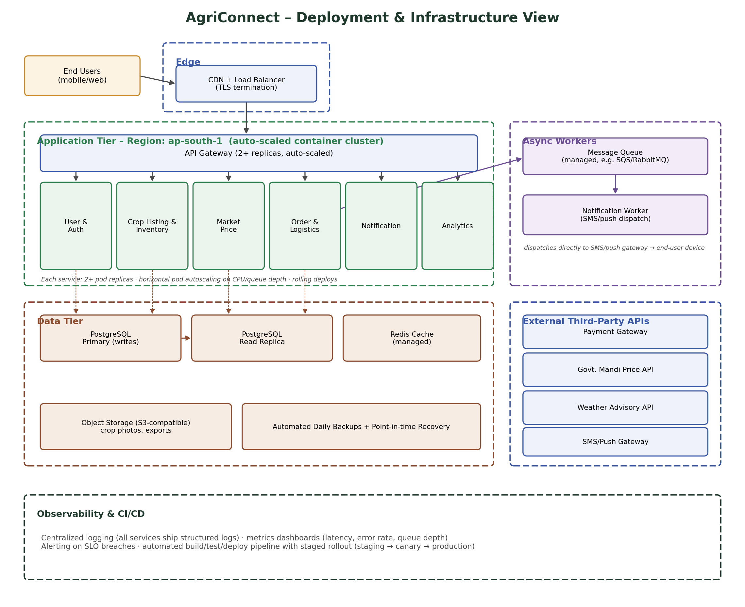
Figure 3: Deployment and infrastructure view for AgriConnect.

Zone-by-Zone Summary
- Edge – a CDN and load balancer terminate TLS and route traffic to the application tier, also caching static assets close to users.
- Application Tier – a single-region, auto-scaled container cluster running the API Gateway and all six microservices, each with at least two replicas and horizontal pod autoscaling based on CPU and queue depth.
- Async Workers – a managed message queue and a Notification Worker process events without blocking the request path, dispatching directly to the SMS/push gateway.
- Data Tier – a PostgreSQL primary handles writes, a read replica serves analytics and reporting queries, Redis serves hot cached data, and object storage holds crop photos, all backed by automated daily backups with point-in-time recovery.
- External Third-Party APIs – the payment gateway, government mandi price API, weather advisory API, and SMS/push gateway, each reached only through the owning service's adapter.
- Observability & CI/CD – centralized logging and metrics dashboards support the 99.5% availability target (NFR-6), with an automated pipeline promoting builds through staging, canary, and production.

9. Design Rationale

9.1 Scalability
Each microservice scales independently, so a spike in price-checking traffic during a harvest window can scale the Market Price Engine without over-provisioning less-loaded services such as Analytics. Horizontal pod autoscaling responds to CPU usage and, for the Order & Logistics Service, to message queue depth. The database read replica offloads analytics and reporting queries from the transactional primary, and Redis caching of price and session data reduces database load for the platform's most frequently read information. The message queue absorbs bursts of order-confirmation notifications during peak selling periods without slowing order placement itself.

9.2 Security
All traffic is encrypted in transit via TLS 1.2 or higher, terminated at the edge. Authentication uses JWT/OAuth2 issued by the User & Auth Service and validated at the API Gateway on every request, with role-based access control enforced for administrative functions (Week 1 NFR-3, NFR-4). Data is encrypted at rest in both the database and object storage. Payment card details are never stored on AgriConnect infrastructure; the Order & Logistics Service holds only a gateway reference and status, delegating card handling and PCI-DSS scope to the payment gateway. The API Gateway also applies rate limiting and input validation before requests reach any service, and all critical transactions are captured in centralized logs to satisfy the Week 1 audit requirement (FR-27).

9.3 Modularity
Service boundaries mirror the six functional modules defined in Week 1 exactly, so a change to a single business requirement maps to a change in a single service rather than a cross-cutting change across the codebase. Services communicate only through versioned REST APIs and the shared event bus, never through a shared database table, which keeps them independently deployable. External integrations are isolated behind adapters inside the owning service (for example, the Market Price Engine's Govt. Mandi API adapter), so a change to a third-party API's contract is contained to one place rather than rippling through the system.

10. Technology Stack Recommendations
The following stack was selected to balance developer productivity, operational simplicity for a small team, and the architectural goals from Section 1.4. All choices favour managed services over self-hosted infrastructure wherever a suitable managed option exists.
Layer | Recommended Technology | Rationale
Mobile Client | React Native | Single codebase for Android and iOS; mature offline-storage libraries suit intermittent connectivity.
Admin Web Dashboard | React.js | Fast to build; keeps the team on a single language across client and admin surfaces.
API Gateway | Managed API Gateway (e.g. Kong or a cloud provider's API Gateway) | Built-in authentication, rate limiting, and routing avoid reimplementing cross-cutting concerns.
Backend Services | Node.js + Express (TypeScript) | Efficient for I/O-heavy API workloads; one language across the stack simplifies hiring and code review.
Primary Database | PostgreSQL (managed) | ACID guarantees suit orders and payments; strong relational and JSON support.
Cache | Redis (managed) | Sub-millisecond reads for price data and session tokens.
Message Queue | Managed queue (e.g. Amazon SQS or RabbitMQ) | Decouples order confirmation from notification dispatch with minimal operational overhead.
Object Storage / CDN | S3-compatible storage + CDN | Durable, inexpensive storage for images with low-latency edge delivery.
Hosting / Orchestration | Docker containers on a managed container service | Portability and autoscaling without a large dedicated operations team.
Monitoring | Centralized logging + metrics dashboard | Required to meet the 99.5% availability target (NFR-6) and to support fast incident response.

11. Non-Functional Requirements Traceability
The table below maps each Week 1 non-functional requirement to the specific architectural decision that addresses it, confirming that every NFR has a concrete architectural response rather than being deferred to “later.”
NFR ID | Week 1 Requirement | Architectural Response
NFR-1 | Performance (3s load on 3G) | Redis caching of hot data, CDN for images, indexed read-replica queries
NFR-2 | Scalability (50,000 concurrent users) | Stateless microservices behind autoscaling groups; horizontal pod autoscaling
NFR-3 | Security (encryption) | TLS 1.2+ in transit; encryption at rest for database and object storage
NFR-4 | Security (RBAC) | Role-based access enforced at the API Gateway and User & Auth Service
NFR-5 | Usability (low-literacy support) | Lightweight mobile client with offline cache; icon-driven navigation at the client layer
NFR-6 | Availability (99.5% uptime) | Multi-replica deployment behind a load balancer; automated backups and PITR
NFR-7 | Localization (3+ languages) | Client-side i18n; localized message templates in the Notification Service
NFR-8 | Compliance (data protection) | Encryption, access control, and audit logging by design; payment tokenization
NFR-9 | Maintainability | Independently deployable microservices aligned to business modules; versioned APIs
NFR-10 | Interoperability | API Gateway plus dedicated adapters for each external system
NFR-11 | Offline Tolerance | Cacheable, versioned GET endpoints support client-side offline caching
NFR-12 | Accessibility | Addressed at the client UI layer; backend returns structured, screen-reader-friendly data

12. Assumptions, Constraints & Limitations

12.1 Assumptions
- A managed cloud provider is available and budgeted for hosting the application, data, and messaging tiers.
- Third-party systems (payment gateway, government mandi API, weather API, SMS/push gateway) expose REST/JSON interfaces with documented rate limits.
- Initial user base and transaction volume fit within a single-region deployment; multi-region is not required at launch.

12.2 Constraints
- The architecture must remain operable by a small engineering team, favouring managed services over self-hosted infrastructure wherever possible.
- Budget favours pay-as-you-go managed services over large upfront infrastructure investment.
- The five-week internship timeline limits this document to logical and deployment architecture; detailed schema DDL and infrastructure-as-code scripts are deferred to Week 3 and Week 4.

12.3 Limitations & Future Considerations
- The current design assumes a single-region deployment; a future multi-region active-active setup would improve disaster recovery but is not justified at current scale.
- Machine-learning-based price prediction and demand forecasting are noted as a future extension to the Analytics & Reporting Service, outside this phase's scope.
- Event sourcing / CQRS was considered but deferred in favour of a simpler request/response model with a single event bus, appropriate for the platform's current scale.

13. Conclusion
This report has translated the twenty-seven functional and twelve non-functional requirements from Week 1 into a concrete, layered microservices architecture for AgriConnect. Six services — User & Auth, Crop Listing & Inventory, Market Price Engine, Order & Logistics, Notification, and Analytics & Reporting — sit behind a single API Gateway, backed by a relational database, a cache, object storage, and a message queue that decouples slow external dependencies from the main request path.
A representative sequence diagram traced the highest-priority order-placement flow end-to-end, a deployment view described how the system is hosted and scaled, and a traceability check confirmed that every Week 1 non-functional requirement has a specific architectural response. This provides a defensible, implementable basis for the Week 3 Module Development task, in which the “Must” priority components identified in Week 1 – chiefly User & Auth, Crop Listing, and Order & Logistics – will be built out first.

